Operating System
CSL303

Project Report

Page Replacement Policy Visualizer



Faculty name: Dr. Asha Sohal

Nishant Rajora 23csu220
Palak Kansal 23csu230
Monika 23csu203
Neha 23csu209

— Semester: 5th, Group: DS-2

Department of Computer Science and Engineering
The NorthCap University, Gurugram- 122001, India
Session 2022-23

1. Introduction

Paging is a fundamental memory management technique used by modern operating systems. However, with limited frames available in physical memory, page replacement policies are required to decide which page to evict when a new page must be loaded.

This project implements a Page Replacement Policy Visualizer that:
- Simulates FIFO, LRU, and Optimal page replacement algorithms
- Displays memory states step-by-step
- Shows total page faults for each algorithm
- Offers both CLI mode and a Tkinter-based GUI mode
- Helps students clearly understand page replacement behavior

2. Objective

The objective of this project is to:
- Demonstrate the working of FIFO, LRU, and Optimal page replacement policies
- Compare page faults for different policies
- Provide an interactive visualization using a GUI
- Make OS concepts easier to understand with real-time simulation

3. System Requirements

Hardware
- Any system capable of running Python

Software
- Python 3.x
- Tkinter (included with standard Python)

4. Architecture Diagram

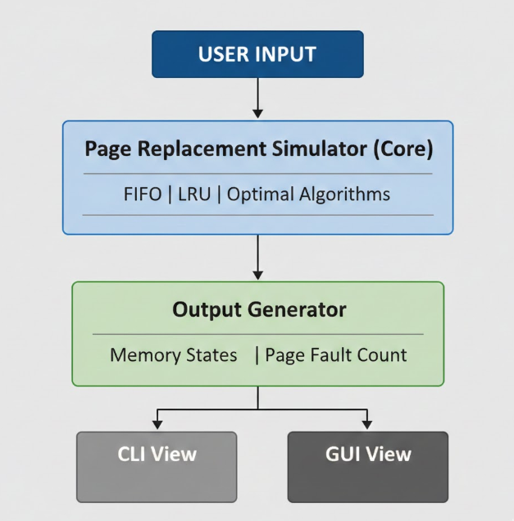

5. Algorithms Used

5.1 FIFO (First-In-First-Out)
- Oldest loaded page is removed
- Simple but not optimal

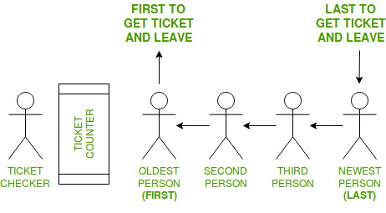

5.2 LRU (Least Recently Used)
- Replaces the page that hasn’t been used for the longest time
- More efficient than FIFO

5.3 Optimal Page Replacement
- Replaces the page that will not be used for the longest time in the future
- Produces minimum page faults (benchmark algorithm)

6. Data Structures Used
Component | Data Structure | Purpose
Memory frames | List | Stores pages
Timestamp for LRU | Dictionary | Tracks last used index
Output logs | List of lists | Stores states after each step
GUI Table | Tkinter Treeview | Displays results visually

7. Implementation Overview

The project is divided into three Python modules (parts):

✔ Part 1 – Core algorithms (FIFO, LRU, Optimal)

✔ Part 2 – CLI Simulator

✔ Part 3 – GUI Application (Tkinter)

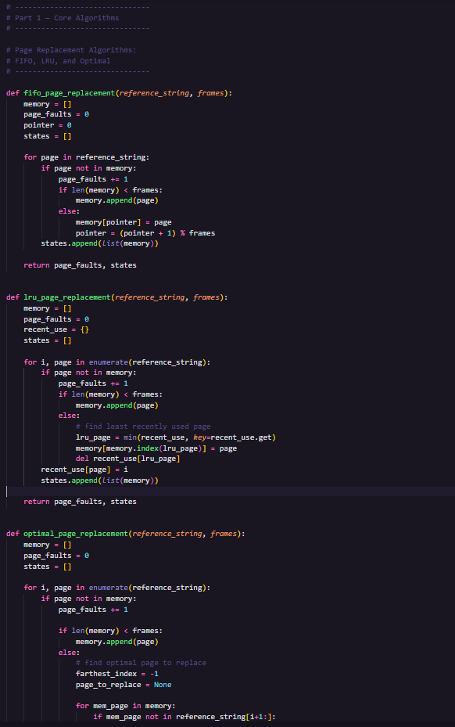

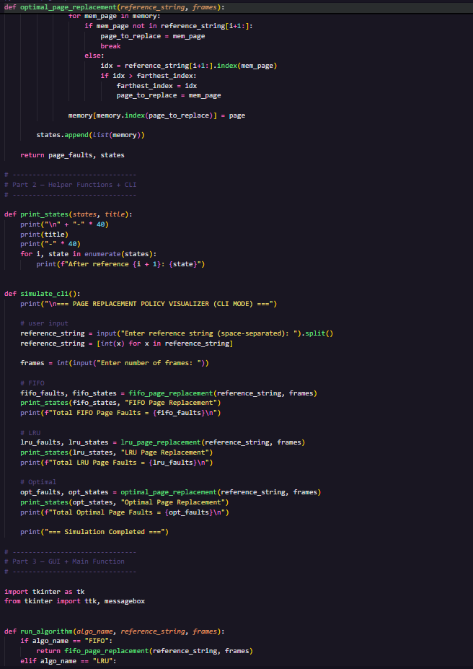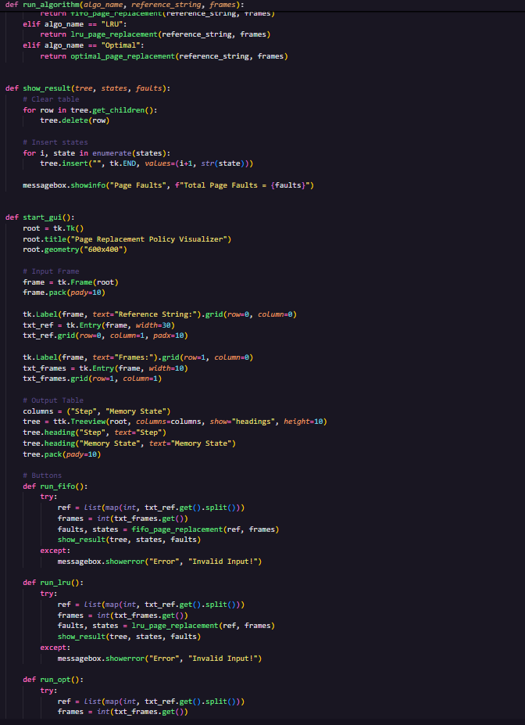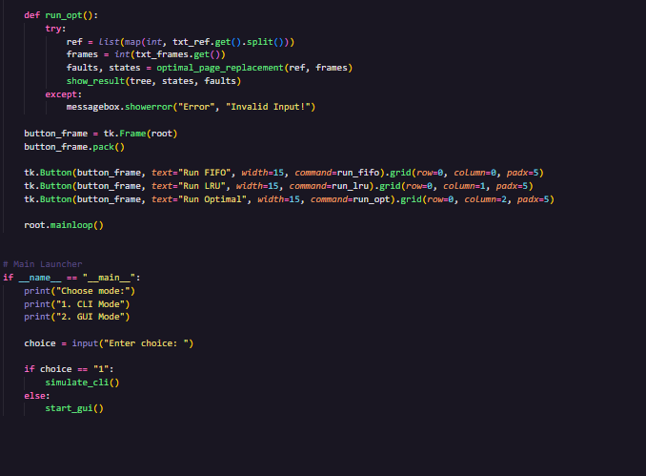

8. GUI Screenshots

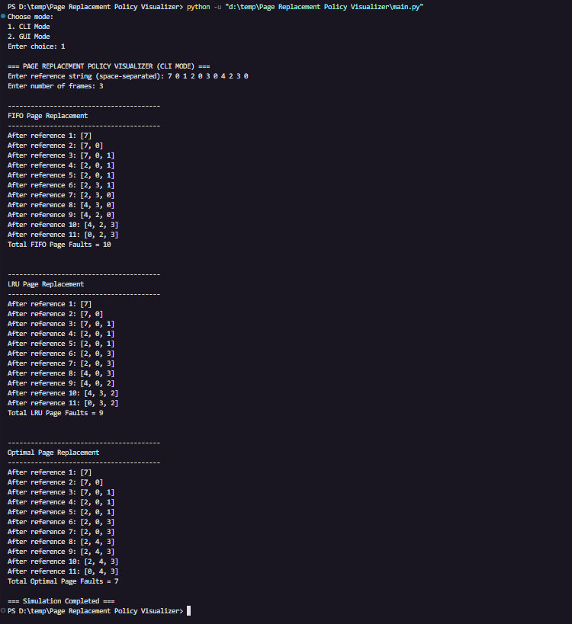

9. Sample Input / Output

Sample Input

Reference String: 7 0 1 2 0 3 0 4 2 3 0

Frames: 3

Sample Output
Algorithm | Page Faults
FIFO | 9
LRU | 8
Optimal | 7

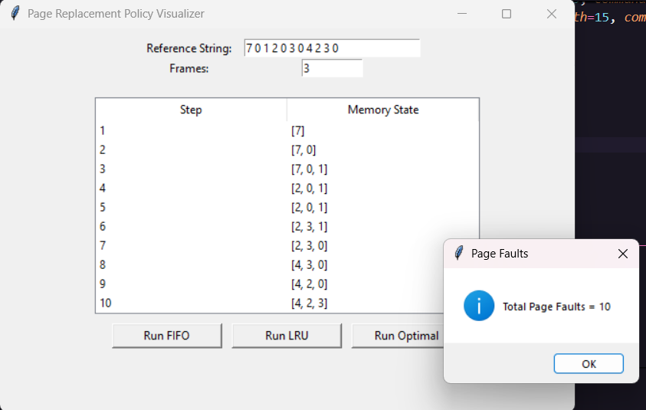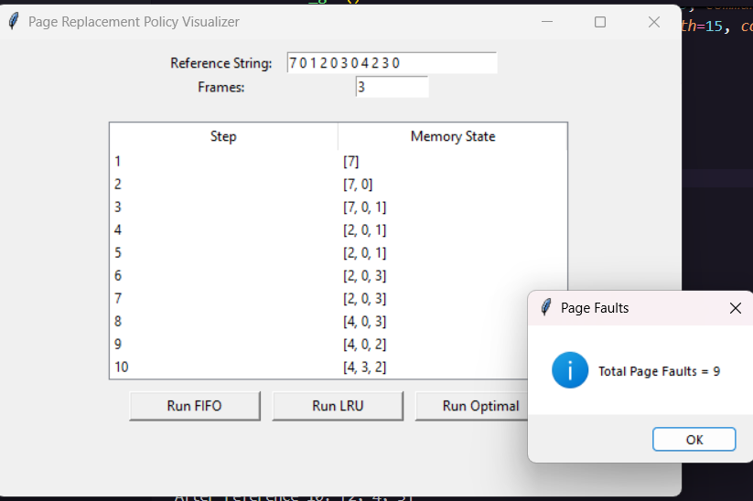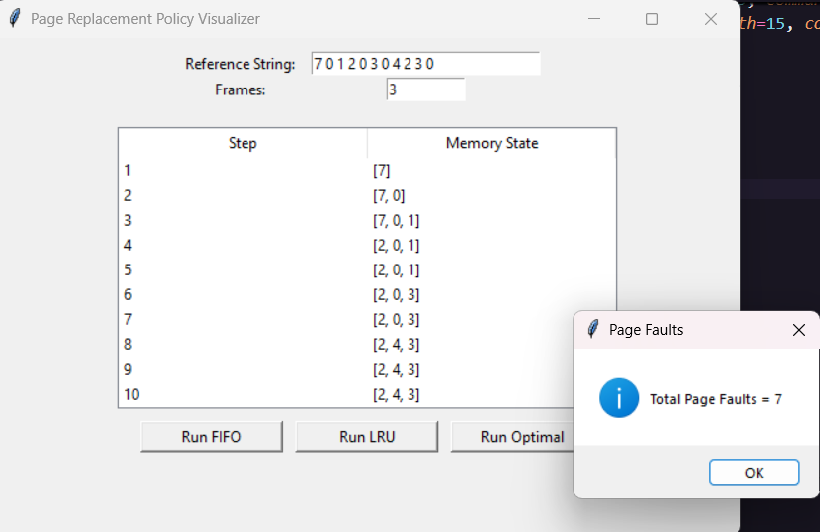

10. Results and Discussion
- FIFO performs poorly in many cases due to the “Belady’s anomaly.”
- LRU generally performs better because it uses past usage to predict future need.
- Optimal gives the least page faults but is not implementable in real OS because it requires future knowledge.

Conclusion:

➡ Optimal < LRU < FIFO
(in terms of page fault count)

11. Time Complexity Analysis
Algorithm | Time Complexity | Explanation
FIFO | O(n) | Simple pointer replacement
LRU | O(n) | Dictionary operations
Optimal | O(n²) | Future scanning for every page

Where n = length of reference string

12. Applications
- Educational OS simulators
- Memory management research
- Comparison of different algorithms
- Understanding performance differences

13. Conclusion

This project successfully demonstrates how page replacement policies work. By using both CLI and GUI simulations, the user can clearly visualize memory states and understand which algorithms produce fewer page faults.

The project also provides a strong foundation for future expansion like:
- Adding LFU, MFU
- Adding graph-based visualization
- Adding performance charts

14. References
- Operating System Concepts – Silberschatz, Galvin
- Modern Operating Systems – Andrew S. Tanenbaum
- Online OS simulators and academic articles

